ME310 – Instrumentation and Theory of Experiments

Lab 2: The Wheatstone Bridge and Strain Measurement

Concepts: Wheatstone bridge, Linearity, Strain Gage, Stresses in cantilever beams, Compensation, Micrometers, Dual Sensitivity
DELIVERABLES: Full lab report (without uncertainty analysis) document, due in next lab period.

- Introduction

The Wheatstone bridge circuit is used very commonly in instrumentation for the comparison and measurement of resistances. In particular, this circuit is used very often in conjunction with strain-gage based transducers, e.g. basic electrical resistance strain gages, load cells and pressure transducers. The Wheatstone bridge circuit is also employed in other applications such as thermistor thermometry and hot wire/film anemometry.

The strain gage is a transducer that is sensitive to strain. The “electrical resistance strain gage” consists of a thin filament with a known resistance that is bonded to a structural element whose strain is to be measured. When an external strain lengthens or shortens the filament its total resistance changes by a small amount ΔR (of the order of 0.1%).

The Wheatstone bridge and the “electrical resistance strain gage” form an excellent combination with the small change in resistance being detected by the Wheatstone bridge. In the “deflection mode” of the bridge, we can obtain a voltage output that is linearly proportional (for small ΔR) to the resistance change caused by the strain.

In practice, however, this voltage is rather small (on the order of millivolts) and it is necessary to amplify the output to yield a signal that is more easily measured. It should be noted that this is one reason bridge circuits are preferred over voltage divider circuits for detecting small changes in resistance. The bridge circuit can be balanced before measurements are made so that only the voltage produced by the change in resistance during the measurement is amplified in the amplifier. Voltage divider circuits produce large DC offsets in their output signals, in addition to small voltage changes during measurement. The large DC offset from a voltage divider circuit can saturate the amplifier, thus rendering the measurement system useless.

Although in principle the amplifier could be a single operational amplifier circuit, a single op amp cannot be used in practice because it cannot provide sufficient gain, therefore the two-stage differential amplifier that the GSTs will have built will be used.

In this experiment you will first study a simple Wheatstone bridge and then measure strain in a cantilever beam by building the basic elements of a strain indicator – a Wheatstone bridge and an amplifier. In fact, considering the cantilever as a transducer for converting force applied to its tip to strain along its length, you will have built an entire force measuring system similar to one used in the wind tunnel experiments!

- Theory

  - Wheatstone Bridge Circuit

There are two ways of using the Wheatstone Bridge: as a null bridge or as a deflection bridge. In this lab you will use it as a deflection bridge. To learn more about using the Wheatstone bridge as a null bridge, see the sources listed in the ‘additional reading’ section of this lab. The deflection bridge consists of four resistors arranged as in Figure 1. An external power supply voltage (“excitation”) V is applied across terminals B and D. The input to the circuit is considered a change in the resistance of the resistors while the output signal is the resulting voltage drop (due to the change in resistance) measured across terminals A and C, V_{AC}.

V_{AC}
A
B
C
D
R₁
R₂
R₄
R₃
V
Figure 1: Simple Wheatstone bridge circuit.

To use the deflection bridge as described above, you need to relate the change of resistance to the change in voltage from the initial state to the final state. A convenient initial state is for V_{AC} to be equal to zero; when V_{AC} is zero, the bridge is said to be balanced. When the bridge is balanced, it can be shown that

(1)

After balancing the circuit, if the resistance of one of the resistors is changed from its initial setting, the voltage V_{AC} will change, thus a change in the resistance can be detected by a change in the voltage. Since V_{AC} is initially equal to zero, the change in V_{AC} (ΔV_{AC}) equals V_{AC} (i.e. ΔV_{AC} = V_{AC} - V_{ACinitial} = V_{AC} – 0 = V_{AC} ). Let R₁ be the resistance that changes. Define its initial value as R₁₀ and the change to be ΔR₁. If a very high impedance meter is used for measurement of V_{AC}, it can be shown that:

(2)

But using Equation 1 this can be reduced to:

(3)

if R₁₀ = R₂ = R₃ = R₄, i.e. all resistances were initially the same,

(4)

Although the voltage V_{AC} is not strictly linear with respect to ΔR₁/R₁₀, for values of 2ΔR₁/R₁₀ negligible compared to 4 (i.e., ΔR₁/R₁₀ << 2) so V_{AC}/V is essentially linearly proportional to ΔR₁/R₁₀. This property of the deflection bridge is often utilized in instrumentation applications. The linear approximation for the bridge response with all resistors equal at initial balance is thus:

(5)

  - Electrical Resistance Strain Gage

The “electrical resistance strain gage” consists of a thin filament with a known resistance that is bonded to a structural element whose strain is to be measured (such as load-bearing bridges, airplane wings, etc.). When the structure undergoes strain, the resistance of the gage changes – it increases for elongation and decreases for compression – by a small amount (provided there are no changes in the temperature of the gage).

Equation 6 states that the fractional change in resistance of the strain gage is a function of the mechanical strain, the Poisson ratio of the strain gage material and the temperature of the strain gage.

(6)

Where:

dR = small change in resistance
R = unstrained resistance of strain gage
ε_{a} = strain along the primary axial direction
ν = Poisson ratio of strain gage material
f(T) = Temperature dependent terms

It is usual practice to define a gage factor F by

(7)

so that F takes the place of all the terms in the square bracket in Equation 6. Therefore, for small but finite changes of resistance,

(8)

The value of F is a property of the gage material and is given by the manufacturer or can be found from calibration. Thus, by measuring ΔR/R and knowing F, the strain ε_{a} can be found. Note that F is a function of temperature unless a compensation gage is used; see next section.

  - Using the Strain Gages with the Wheatstone Bridge

The Wheatstone bridge can be used as a means of determining ΔR/R to find the strain ε_{a}. In this arrangement, the strain gage would replace resistor R₁ in the circuit of Figure 1. The ΔR₁/R₁₀ values due to strain are typically of the order of 1.0x10⁻⁸ and hence we can assume from Equation 4:

(9)

provided R₁₀ = R₂ = R₃ = R₄. Therefore,

(10)

Recall from the previous section that changes in temperature also affect the resistance of the strain gage; this property of the strain gage is called “dual sensitivity.” In fact, the change in the resistance of a strain gage due to changes in temperature is actually comparable to the changes produced by the mechanical strain itself. Therefore a practical problem associated with using strain gages is how to account for this temperature dependence. The problem can be overcome if the arrangement of the bridge circuit is modified to that of Figure 2 to include a second strain gage that is maintained at the same temperature as the first gage. The first gage is known as the active gage, and the second gage is called a compensation gage. It can be shown (Pre-lab: Show this by applying Ohm’s and Kirchoff’s Laws and dropping nonlinear terms) for identical strain gages in the adjacent arms 1 and 2 (as in Figure 2) that

, (11)

where ΔR₁ and ΔR₂ are changes in R₁ and R₂ from their values at initial balance. ΔR₁ is due to two causes: mechanical strain change and temperature change. ΔR₂ is due only to temperature changes, allowing the mechanical strain to be isolated. Let ΔR_{S(1,2)} and ΔR_{T(1,2)} be the changes in resistance due to mechanical strain and temperature respectively, with the subscript numerals standing for strain gage 1, and strain gage 2. For the configuration in Figure 2, ΔR_{S2} = 0 (because there is no stress placed on it) and ΔR_{T1} = ΔR_{T2} (because the strain gages are identical). Thus Equation 10 becomes

(12)

and Equation 9 holds independent of temperature changes. This is called “temperature compensation,” and is another reason why bridge circuits are preferred over voltage divider circuits in many applications – there is no way to do temperature compensation with a voltage divider.

R₂
V
Gage 2
Specimen
R₃
R₄
Gage 1

R₁

Compensation
Gage
Figure 2: Temperature compensation arrangement for electrical resistance strain gages.

A different arrangement of strain gages can also accomplish temperature compensation, and it can also increase the sensitivity of the measurement. Instead of using a strain gage mounted on a separate (non-strained structural element) as the compensation gage, it can be mounted on the opposite side of the strained element. This arrangement means that the two strain gages will be subject to equal, but opposite strains, (i.e. one will be in tension and the other compression), and additionally they will still be subject to the same temperature changes. Let ΔR_{S1} = ΔR_{S2} and ΔR_{T1} = ΔR_{T2}. Thus, Equation 10 becomes

(13)

And thus, Equation 9 becomes

(14)

The arrangement with only one gage sensing strain is called a “quarter bridge,” since only one quarter (one arm) of the bridge is participating in the active measurement. The other arrangement, with both gages sensing the mechanical strain is called a “half bridge” for obvious reasons. Discussion question: What practical considerations are required for this approach to work correctly?

  - Theoretical Deflection and Strain of a Cantilever
The following derivation relates the load “P,” deflection “y” and strain “ε_{a}” for a cantilever beam. Note that for this lab exercise, the strain direction will be along the main axis of the sample, referred to as the “longitudinal” axis, or simply, “axial” strain. See Figures 3 and 4.

Figure 3: Geometric quantities used in deflection derivation.
y
x
Micrometer
a
m
P
L
Beam Cross Section Section
h
b
c = h/2

I = bh³/12

Clamp
Micrometer
Cantilever
Beam

Strain Gauge Element
Deflection Gauge
Loading
Hook

Base
Figure 4: Schematic of cantilever beam and loading device.

To find the deflection y at position x on the beam, Equation 15 must be solved using appropriate boundary conditions.

(15)

in which is the moment at a position x due to load P, I is the moment of inertia of the beam (see Figure 3) and E is Young’s Modulus of the beam material. The boundary conditions at x = 0 are and y = 0. y(x) can be found by integrating Equation 15 twice and applying the boundary conditions.

, C1 found from boundary conditions.

, C2 found from boundary conditions.

At the end of the beam, x = L the deflection is:

.

At the center of the micrometer, x = m, the deflection is

.

At the center of the strain gage, x = a, the strain is

,

where σ_{a} is the stress producing the strain. Prelab: Look up E_{Aluminum} for the lab spot check. Remember to record and cite the source.

- Procedure
The experiment consists of five parts. In the first part, a Wheatstone bridge circuit with known resistors is balanced using a decade resistance box (DRB) as the variable resistance. In the second part the DRB is used to study the Wheatstone bridge as a deflection bridge by measuring the output voltage variation for changes in the resistance of the DRB. In the three remaining parts, strain in a cantilever beam is measured with electrical resistance strain gages, utilizing the quarter bridge and half bridge configurations.
You will use a custom-designed two-stage inverting differential amplifier board (nominal gain of 100) to amplify the output from some of the measurements. The corresponding circuit diagram for this amplifier appears in the appendix of this manual.

  - Balancing the Bridge
Set up a circuit as in Figure 1 with R₂ = R₃ ₌ R₄ = 10 kΩ. Use a DRB in place of R₁. Use a DC power supply to supply V and set it to 15.0 V. Use a multimeter to measure V_{AC}.

Before building the circuit, measure and record the values of the individual resistors using the multimeter. You cannot measure the resistance of the individual components when they are parts of the bridge. Discussion question: Why not? Keep track of specific values of R₂, R₃, and R₄. Next, balance the bridge by changing the resistance of R₁ (by flipping the appropriate switches on the DRB). Recall from the first lab that you cannot trust the resistance indicated on the decade resistance box: be sure to measure the resistance of the DRB that results in balancing the circuit! Draw a block diagram of the measurement setup.

SPOT CHECK: Make sure that the value of resistance required for balancing the bridge is reasonable by comparing it to the value predicted by theory (i.e. use Equation 1 with the measured values of R₂, R₃, and R₄ to solve for R₁ and compare this value with the one you measured).

  - Deflection Bridge
Starting with the bridge balanced, (i.e., V_{AC} ~ 0), decrease the resistance on the decade box in steps of 20Ω (i.e. 20 Ω less than the resistance on the decade box necessary to balance the bridge) to a total decrease of 100 Ω, then in steps of 100 Ω to a total decrease of 500 Ω, and then in steps of 500 Ω to a total decrease of 3000 Ω. Again, be sure to measure the resistance of the decade resistance box for each step, instead of trusting the settings on the box itself. Record the output V_{AC} for each step, noting the sign. Balance the bridge before continuing (set V_{AC} = 0). Next, increase the resistance by the same steps as before and record the output, again noting the sign. If your experimental setup changed from Sec. 3.1, draw a new block diagram.

  - Axial strain in a Cantilever – Quarter Bridge
There are two aluminum sections provided – the first is fixed in a loading device as a cantilever beam while the second is not mounted. The first section has two strain gages mounted on it, one on the top surface and one on the bottom surface directly below the former. Both gages have their elements oriented along the longitudinal axis of the beam.

Make sure to take all the dimension measurements on the loading device that are needed for the analysis; see Figures 3 and 4. BE VERY CAREFUL WHEN HANDLING THE STRAIN GAGES, SINCE STRAIN GAGES AND CONNECTING WIRES ARE VERY DELICATE!

Build a Wheatstone bridge circuit on the breadboard as shown in Fig. 5. Connect the strain gage on the upper surface of the cantilever beam in place of the active gage and the gage mounted on the unloaded bar in place of the compensation gage. Use a precision 121 Ω resistor for R₄ and the decade resistance box in place of R₃. Apply a bridge excitation of 5.0 volts (from the DC power supply).

With the beam unloaded, rotate the micrometer clockwise until it touches the beam surface very lightly (you can use the output of your strain indicator to help you with this). Record the micrometer reading.

Bridge
Output
V_{AC}
Compensation gage
V =5 V
Active gage
on top
200 Ω
pot.
121 Ω

Figure 5: Quarter-bridge circuit.

Next, use the differential amplifier to compare output with an unamplified and amplified state. Referencing Fig. 6 and keeping the current set of cables in place (to simultaneously measure the unamplified output), use a pair of alligator clips to connect the bridge outputs to the ‘Signal_Input_pos1’ and ‘Signal_Input_neg1’ connections on the amplifier board. Use a set of clip-to-banana cables to connect the ‘Signal_Output_pos1’ and ‘Signal_Output_neg1’ connections to the other input of the multimeter. Power the differential amplifier with ±15 V_{DC} (to the corresponding ±15V terminals on the amplifier board) and check that the amplifier is working properly.
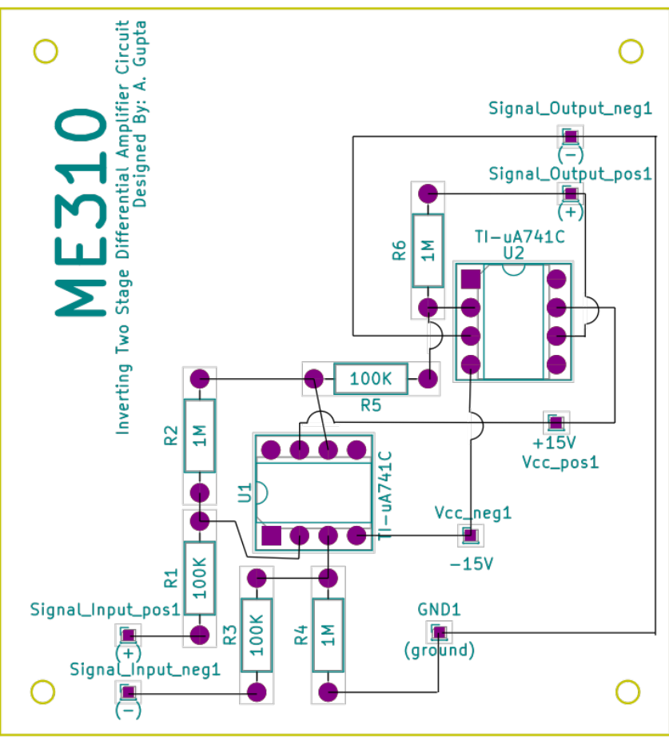
Figure 6: Circuit diagram for the 2-stage inverting differential amplifier.

At this point, the multimeter should have two inputs (unamplified and amplified) that you can read by toggling the ‘front/rear’ switch to alternate between the inputs. If your multimeter has only a single input terminal then acquire these two data sets separately.

Measure the unamplified voltage V_{AC} with no load applied to the cantilever beam (also make sure that the micrometer on the loading device is not touching the beam!). Adjust the variable resistor until the output becomes zero, (or as close as you can come to zero), record this value – it is the zero offset of your system. Load the cantilever beam with 200 grams. Measure the outputs of the bridge and amplifier and record these values. The change in amplifier output should be roughly 100 times the change in the Wheatstone bridge output.

SPOT CHECK: Calculate and compare theoretical and experimental strain values for the 200 gram load before proceeding. Note that you will need Young’s Modulus for aluminum.

If you come this far, you have built the “strain indicator” satisfactorily. You can now start taking data.

Unload the cantilever beam and recheck and record the zero-offset. You do not have to re-zero the bridge, just record the new offset.

Starting with no load, increase the load by 50 grams. Record the amplified and unamplified strain indicator outputs. Measure and record the beam’s deflection using the micrometer. Unload the cantilever and recheck and record the zero voltage offsets and deflection. Be very careful not to alter the beam position due to the micrometer contact force!

Repeat the steps until the applied load is 200 grams, measuring the voltage and deflection for each step. Remember to draw a new block/wiring diagram. Unload the beam and turn the micrometer head counter-clockwise until the deflection gage no longer makes contact with the beam surface.

If the outputs are unstable, you should make multiple measurements, both loaded and unloaded, at each value of loading so you will have sufficient data to determine a mean value, and a precision uncertainty in ΔV_{AC}. The system is very sensitive to vibration, so be careful not to bump the table, wires, etc.

  - Axial Strain – Half Bridge
Turn off the power supply to the Wheatstone bridge and reconfigure the bridge into a half bridge as shown in Fig. 7 by replacing the compensating gage mounted on the non-strained beam by the gage on the lower side of the mounted beam. Readjust the decade resistance box until the bridge is balanced. Record the amplifier and bridge output and micrometer reading.
Bridge
Output
V_{AC}
Active gage
on bottom
V=5 V
Active gage
on top
200 Ω
pot.
121 Ω

Figure 7: Half-bridge Circuit.

Apply loads of 50 grams to the cantilever beam until you reach a maximum of 200 grams as before and measure the strain indicator outputs (both amplified and un-amplified, both loaded and unloaded for each load) and beam deflection. Draw a final block/wiring diagram for this setup.

3.6 Step-by-step Procedure List (Fill in the blank setting spaces!)
3.1 Balancing the Bridge
- Measure & record the resistance of resistors to be used in Wheatstone Bridge;
- Build Bridge circuit (Fig. 1) with bridge arms 2, 3, 4 set to __kΩ. Use DRB for arm 1;
- Balance bridge by adjusting resistance of DRB;
- Measure & record DRB resistance setting that resulted in balanced bridge;
- Perform first Spot Check;
- Draw block diagram of experimental arrangement.
3.2 Deflection Bridge
- Recording output voltage and DRB resistance for each step:
  - Decrease DRB resistance in five steps of 20Ω (-100Ω total);
  - Decrease DRB resistance in four steps of 100Ω (-500Ω total);
  - Decrease DRB resistance in five steps of ____Ω (-3000Ω total);
  - Starting from zero again, repeat previous 3 steps, increasing the resistance instead of decreasing;
3.3 Quarter Bridge
- Measure & record specimen dimensions (length l, width b, thickness h, distance from root to center of gage a, distance from root to center of micrometer m);
- Construct Wheatstone Bridge: set upper gage as the ____ gage and unloaded gage as the ____________ gage; use 121Ω resistor for arm 4 and the decade resistance box for arm 3;
- Power the bridge with a 5 V_{DC} supply;
- Check the 2-stage amplifier (from the GSTs) output for proper operation;
- Connect output of bridge circuit to input of differential amp;
- Connect output of amp to front panel input of multimeter and output of bridge circuit to multimeter (to measure unamplified output as well);
- Measure unamplified voltage V_{AC} and micrometer reading in the unloaded condition and no contact from micrometer;
  - Adjust decade resistance box until bridge output is zero; record resulting voltage;
- Load cantilever beam with 200 g and adjust micrometer until contact is made;
- Measure and record bridge and amplifier output and micrometer reading;
- Perform second Spot Check;
- Unload beam; measure and record new zero offset (do not adjust);
- Increase load to 200 g in ___ g steps; record outputs for bridge, amplifier, and micrometer readings for each load;
- Measure & record readings each time load is changed;
- Turn off bridge power, unload beam and reset micrometer. Draw new block and circuit diagram.
3.4 Axial Strain: Half Bridge
- Replace compensation gage with active gage mounted on bottom side of cantilever beam;
- Turn on bridge power supply; adjust decade resistance box to balance bridge output;
- Record amplifier and bridge output and adjust and record micrometer reading;
- Repeat quarter bridge procedure (50 g steps to 200 g total, measure outputs);
- Draw new block and wiring diagram and turn off bridge power supply.
- Unload beam and adjust micrometer until contact is no longer made;
- Using a set of calipers, determine the unit of the micrometer dial.

- Results and Discussion
1. For the deflection bridge, plot the measured ratio V_{AC} /V as a function of ΔR₁ / R₁₀. Is it linear? Discuss this curve. Use two graphs for this part, one with ΔR₁ between -100 ohms and 100 ohms and another with ΔR₁ between -3000 ohms and +3000 ohms. In addition to the measured data, plot the non-linear and linear theories (Equations 4 and 5, respectively).

2. What is the input range for a linearity error less that 1%? Determine it from your experimental data V_{ACexp} and quantify linearity error via , where V_{AClin} is obtained from Eq. 12.

3. Given the gage factor F=2.125, calculate the axial strains for the different loads from the strain indicator outputs (for the quarter bridge and half bridge, both un-amplified and amplified). Don’t forget to include the amplifier gain in your calculations.

4. Compare the axial strain obtained during the experiment with the theoretical values expected. Also compare the measured deflections with the theoretical values.

- Additional Reading
Dally, J.W., Riley, W.F., and McConnell, K. Instrumentation for Engineering Measurements. 2nd ed. John Wiley & Sons, 1992. Pgs: 85-91, 131, 135, 192-238.

Beckwith, T.G., Marangoni, R.D., Lienhard, J.H. Mechanical Measurements. Reading, Massachusetts: Pearson Prentice Hall, 2007. Pgs: 413-430.

Holman, J.P. Experimental Methods for Engineers NY: McGraw-Hill, 1971. Pgs: 110-117, 362-370

Figliola, R.S. and Beasley, D.E. Theory and Design for Mechanical Measurements. 2nd ed. New York: Wiley, 1995. Sections 6.5, and 11.3-11.5.

- Authors
Drs. B. Bharadvaj, M. Isaacson, R.G. Holt, and C.H. Farny.
Most recent revision: September 2019.

- Appendix
The circuit has a nominal gain of 100 and will saturate for input voltages greater than 0.15 V_{DC}.
Figure A1: Wiring diagram for the two-stage differential amplifier.
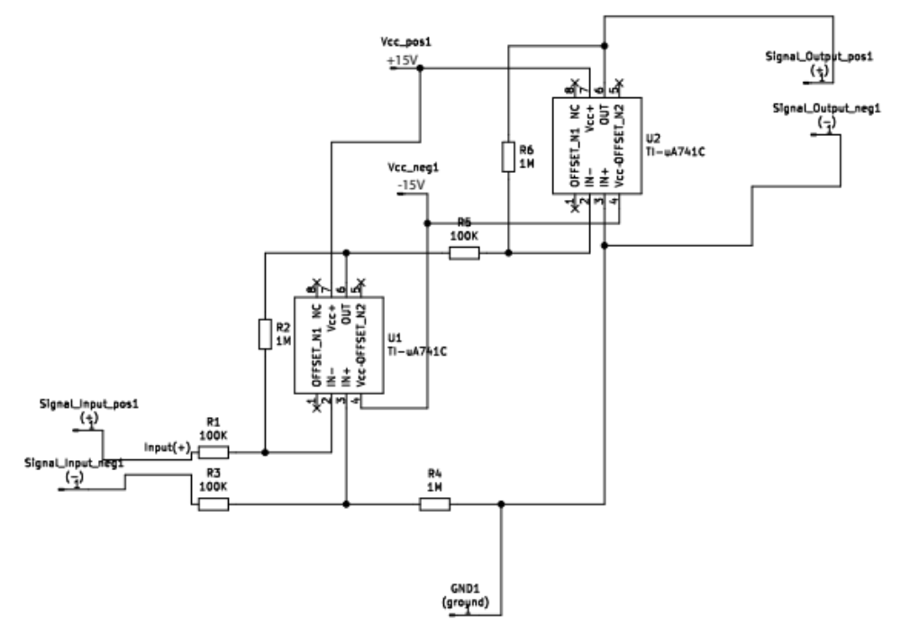
Figure A2: Board layout for PCB.

